**DAILY ONLINE ACTIVITIES SUMMARY**

|  |  |  |  |  |  |  |  |  |
| --- | --- | --- | --- | --- | --- | --- | --- | --- |
| **Date:** | **28-05-2020** | | | | | **Name:** | **Sinchana** | |
| **Sem & Sec** | **6 B** | | | | | **USN:** | **4AL17CS117** | |
| **Online Test Summary** | | | | | | | | |
| **Subject** | | **OS** | | | | | | |
| **Max. Marks** | | **30** | | **Score** | | | **27** | |
| **Certification Course Summary** | | | | | | | | |
| **Course** | **The complete cyber security course** | | | | | | | |
| **Certificate Provider** | | | **Udemy** | | **Duration** | | | **12.0 hours** |
| **Coding Challenges** | | | | | | | | |
| **Problem Statement: 1.balanced bracket 2.digit root 3.reducing array** | | | | | | | | |
| **Status: Success** | | | | | | | | |
| **Uploaded the report in Github** | | | | | **Yes** | | | |
| **If yes Repository name** | | | | | **coding** | | | |
| **Uploaded the report in slack** | | | | | **Yes** | | | |

Online Test Details: (Attach the snapshot and briefly write the report for the same)

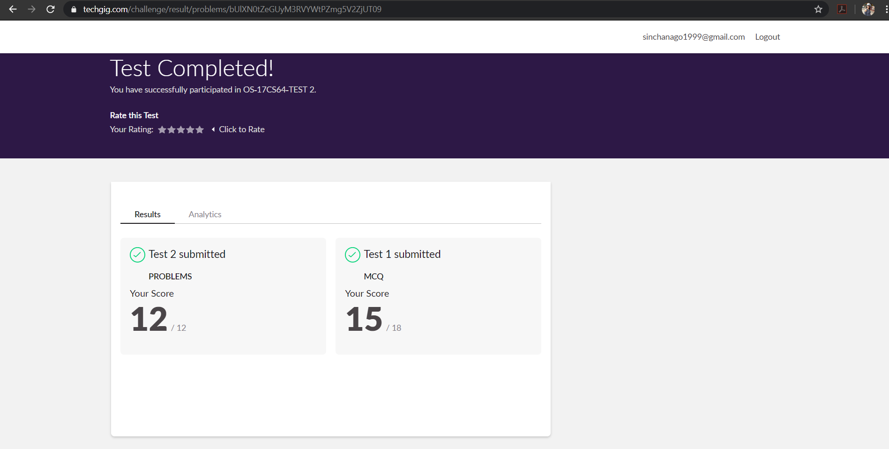

The test was held between 9:10 am to 10:00 am. It consisted of 2 rounds and the total marks assigned was 30.The above snapshot is the output of my 1st IA test.

Certification Course Details: (Attach the snapshot and briefly write the report for the same)

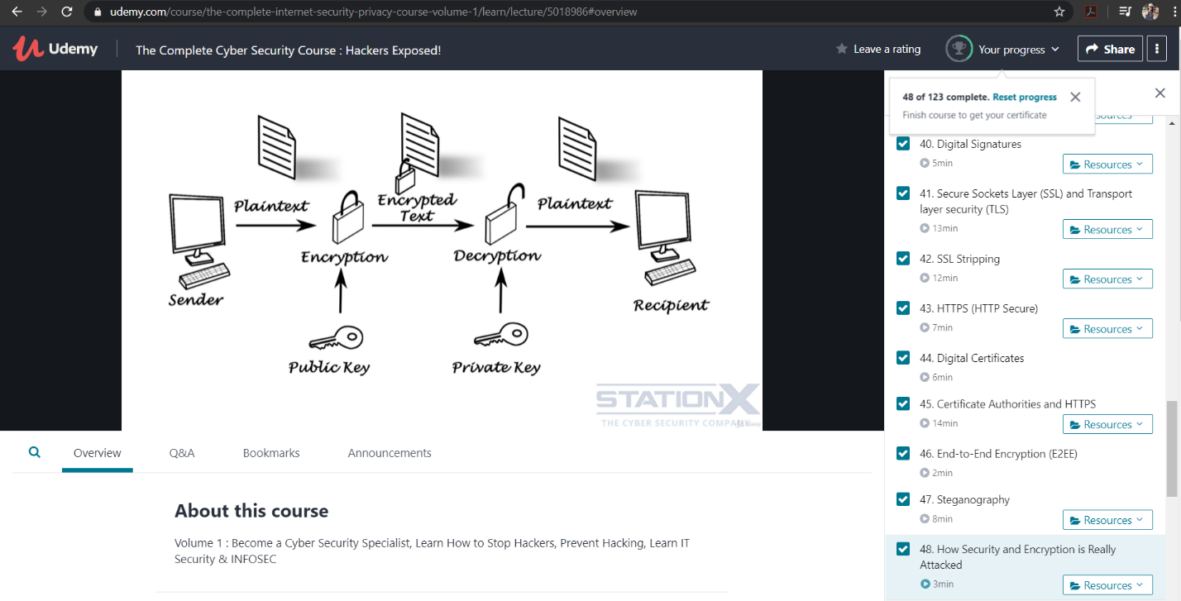

Online Certification Course Summary: Today I have learnt about how security and encryption is attacked in day to day life. And also learnt about the preventive measures that can be taken.

Coding Challenges Details: (Attach the snapshot and briefly write the report for the same)

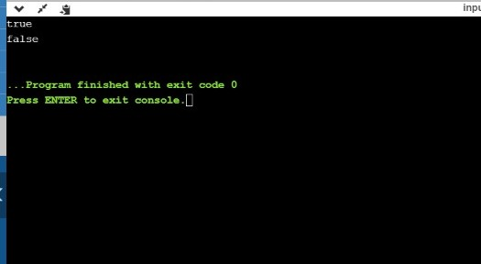

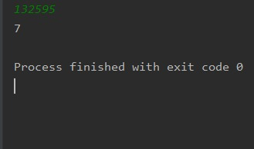

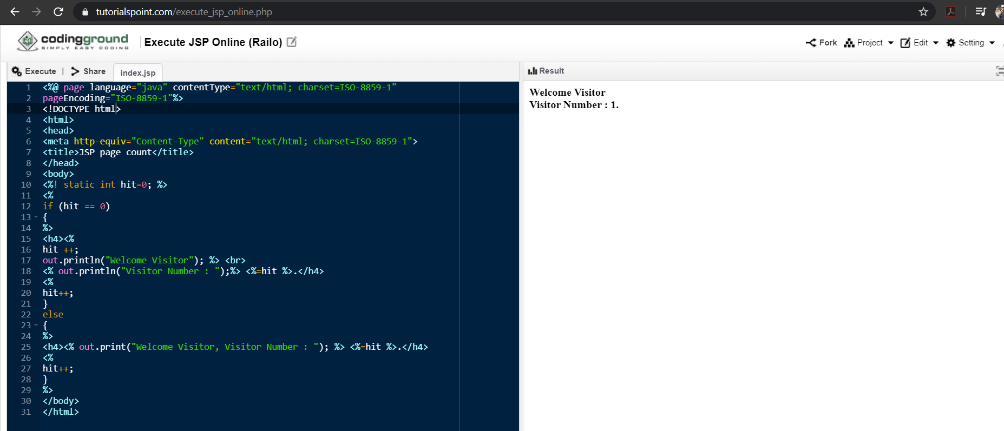

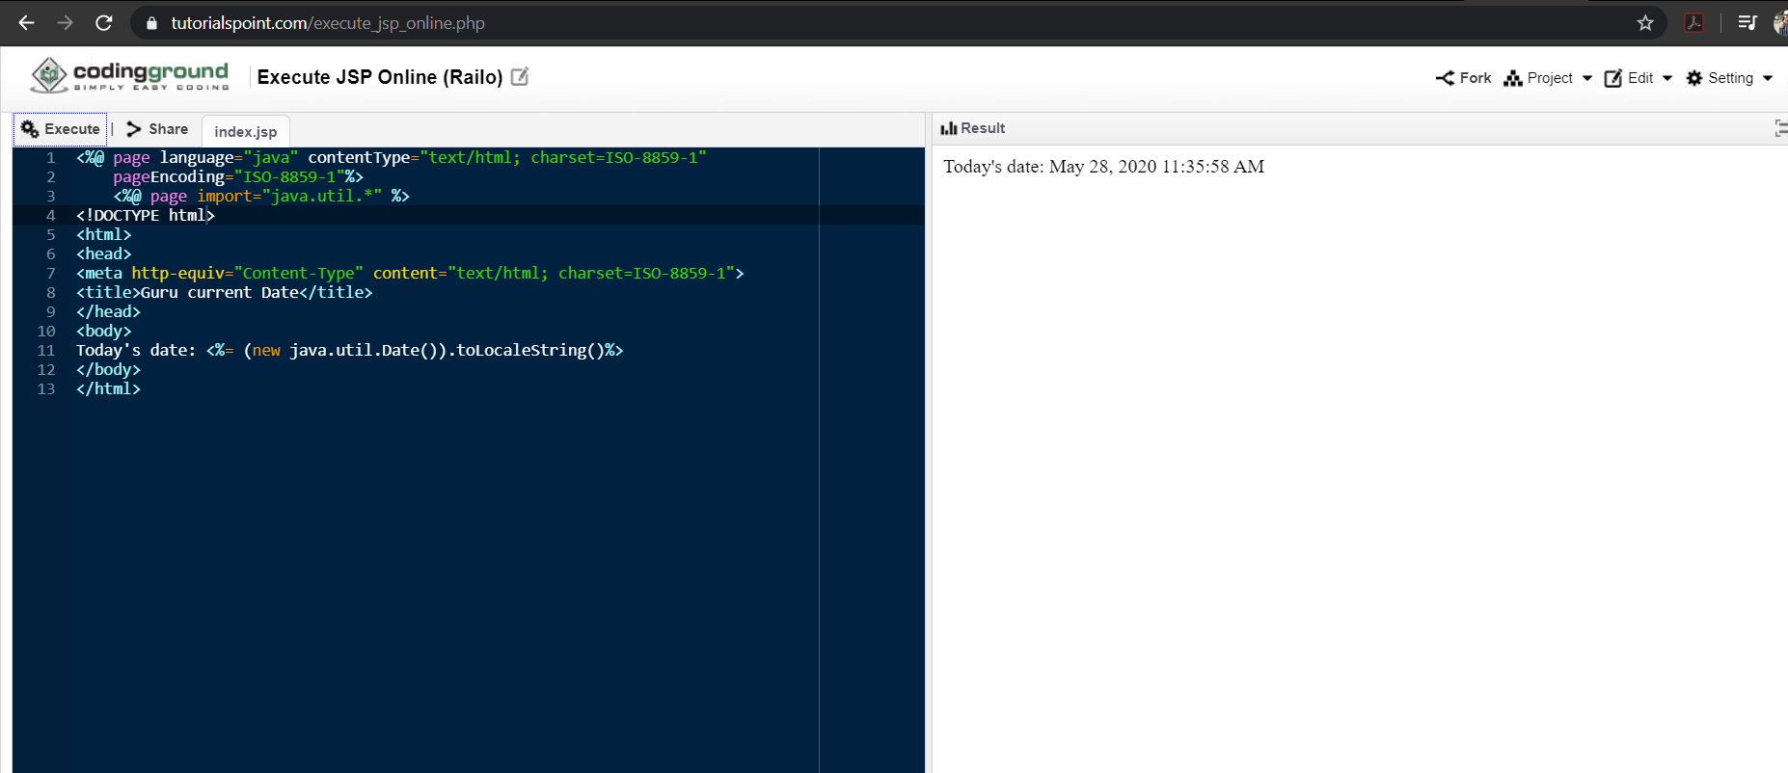

Link in GitHub : <https://github.com/sinchana514/coding>

<https://github.com/sinchana514/coding/tree/master/28th%20may>